Business Template

Subject areas
Logo / Image

Contents
1 Business Description 3
1.1 Business background 3
1.2 Problems. Current Situation 3
1.3 The benefits of implementing a database. Project Vision 3
2 Model description 3
2.1 Definitions & Acronyms 3
2.2 Logical Scheme 3
@

Business Description

Business background
This model connects job candidates with employers; it evaluates each candidate and makes a record about their current position, can be used in probably every job category

Problems. Current Situation
Lot of information would need to be put it manually so it is time consuming and querying this especially into candidates and their skills area would be expensive

the Benefits of implementing a database. Project Vision
This model does the skill matching well and give a lot of freedom to candidates to describe their skills, from the recruiters’ side it gives a great platform to plan the interviews and evaluate the candidates, companies have an easy platform where they can ask for the service of the recruitment company

Model description

Definitions & Acronyms
Company- an org that posts jobs for recruitment companies to pick up, POC here means person of contact
Jobs- these are the jobs that the company posts, isActive means if the job listing is still available for recruiters to pick up and is a boolean
Recruiter- these are the recruiters that work with the job applications and interviews
Job_application- is the application that the candidates submit(application_CV_link here should an URL)
Candidates- this table describes general information about the candidates
Job_skill and candidate_skill- these tables are there to handle m:m relationships (isRequired is a Boolean and means if the skill is required for the job or not
Skills- this table describes candidates skills
Interviews info table has the information about the interview details and interview_feedback has the evaluation/assessment of the candidate, interview_type here can mean if it is technical or general or other types
Education_information table has the info about where the candidate got the education if he got it at all, education level here can mean high-school, university, masters and so on
From the real world scenario I will explain why I decided to choose the relationship on each table, company can have many job listings, recruiters can have many jobs that they can search candidates for, one job can have many applications, one job can have many skill that it requires, one recruiter can have many interviews, one interview can have many feedbacks, one candidate can have many interview, one candidate can have many job applications, one candidate can have many skill, one candidate can have many education facilities finished

Not null constraints on company_name, company_number, company_poc, company_email, job_descr,quantity_needed, job_location, salary, posting_date, closing_date, isActive, recruiter_name, recruiter_email, recruiter_number, isRequired, application_date, application_cv_link, skill_name, interview_date, interview_location, interview_type, candidate_name, candidate_surname, candidate_email, candidate_number, education_level, education_facility, rating, strengths, weaknesses. (drawsql doesn’t have constraints I put nullable on some that could be null in the first submition)

Logical Scheme
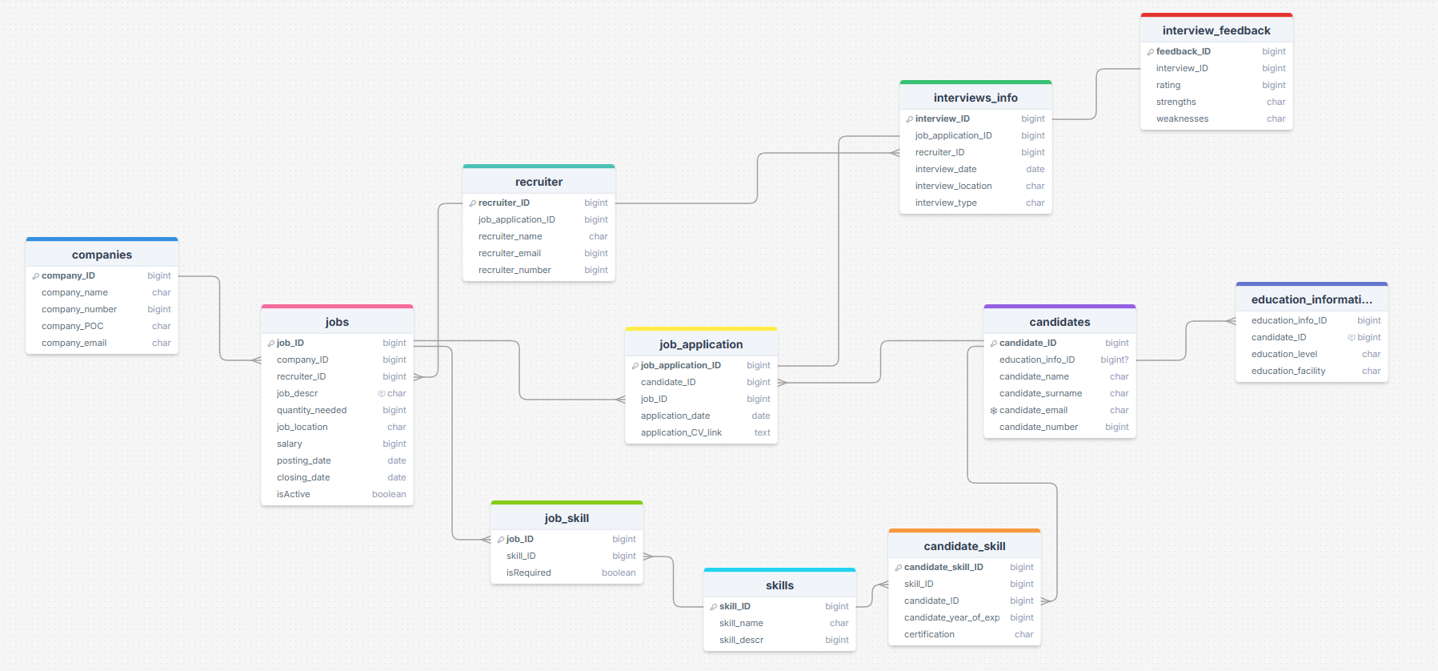

Objects
All data types are present on the model itself
Table Description
<description>

Table Name | Field name | Field Description | Data Type
companies | company_ID | Autoincrement, PK | Int
 | Company_name | Name of the company | varchar
 | Company_number | Number of a company | int
 | Company_POC | Company person of contact | char
 | Company_email | Email of the company or a person | char
Field Name 1 | Company_name | Company_number | Company_poc | Company_email
1 | abc | 12345678 | alisa | abc@gmail.com

Table Name | Field name | Field Description | Data Type
jobs | Job_ID | Id,PK | Int
 | Company_ID | Fk | Text
 | Recruiter_ID | Fk | Int
 | Job_descr | Describes the job | Char
 | Quantity_needed | How many jobs they need | Int
 | Job_location | Location of the job | Char
 | Salary | Salary avg | decimal
 | Posting_date | Posting date | Date
 | Closing_date | Closing date | Date
 | IsActive | If the job is open | bool
Job_ID | Company_ID | Recruiter_ID | Job_descr | Quantity needed | Job_location | Salary | Posting_date | Closing_date | isACTIVEI
1 | 1 | 1 | electrician | 5 | tbilisi | 5000 | 25/02/2002 | 25/02/2003 | TRUE

Table Name | Field name | Field Description | Data Type
recruiter | Recruiter_ID | Autoincrement, PK | Int
 | Job_application_ID | FK | int
 | Recruiter_name | Name of the recruiter | Char
 | Recruiter_email | Recruiter mail | Char
 | Recruiter_number | Number of the recruiter | Int
Recruiter_ID | Job_application_ID | Recruiter_name | Recruiter_email | Company_number
1 | 1 | John | John@gmail.com | 123154616

Table Name | Field name | Field Description | Data Type
Interviews_info | Interview_ID | Autoincrement, PK | Int
 | Job_application_ID | FK | int
 | Recruiter_ID | FK | int
 | Interview_date | Date of an interview | Date
 | Interview_location | Location of the interview | Char
 | Interview_type | Type of an interview | Char
Interview_ID | Job_application_ID | Recruiter_ID | Interview_date | Interview_location | Interview_type
1 | 1 | 1 | 25/02/2002 | Tbilisi,bahg 12 | Technical
Feedback_ID | Interview_ID | rating | Strengths | Weaknesses
1 | 1 | 81 | Big muscles | Very slow

Table Name | Field name | Field Description | Data Type
Job_application | Job_application_ID | Autoincrement, PK | Int
 | Candidate_ID | FK | int
 | Job_ID | FK | Int
 | Application_date | Date that the application was submitted | date
 | Application_CV_link | Link of a cv | char
Job_application_ID | Candidate_ID | Job_ID | Application_date | Application_CV_link
1 | 1 | 1 | 25/02/2002 | www.cv.com
candidates | Candidate_ID | Autoincrement, PK | Int
 | Education_info_ID | FK | int
 | Candidate_name | Candidate name | char
 | Candidate_surname | Surname of the candidate | char
 | Candidate_email | Mail of candidate | Char
 | Candidate_number | Num of candidate | Char
Education_information | Education_info_ID | Autoincrement, PK | Int
 | Candidate_ID | FK | int
 | Education_level | Level of education they have | char
 | Education_facility | What they graduated from | char

Candidate_ID | Education_info_ID | Candidate_name | Candidate_surname | Candidate_email | Candidate_number
1 | 1 | bert | kranski | Bkan1@emai.com | 1235131251

Job_skill | Job_ID | Autoincrement, PK | Int
 | Skill_ID | FK | int
 | isRequired | If the skill is required for job | char
Education_info_ID | Candidate_ID | Education_level | Education_facility
1 | 1 | High school | N31 public school

Job_ID | Skill_ID | isRequired
1 | 1 | TRUE

skills | Skill_ID | Autoincrement, PK | Int
 | Skill_name | Underwater electritian | char

Skill_ID | Skill_name
1 | Underwater electritian
Candidate_skill | Candidate_skill_ID | Autoincrement, PK | Int
 | Skill_ID | FK | int
 | Candidate_ID | FK | int
 | Candidate_year_of_exp | Year of experience | int
 | certification | Certification that candidate has | Char

Table Name | Field name | Field Description | Data Type
Interviews_feedback | feedback_ID | Autoincrement, PK | Int
 | Interview_ID | FK | int
 | Candidate_ID | FK | int
 | rating | Rating out of 100 | int
 | Strengths | Strength of an candidate | char
 | Weaknesses | Weakness of a candidate | Char

Candidate_ID | Education_info_ID | Candidate_name | Candidate_surname | Candidate_email
1 | 1 | 1 | 5 | Certificate of harvard

